Full Name | Vallapu Sai Shyam
Batch | MS FSD DEC 2021 Cohort 1
Project Name | Quiz9
Project Submission Date | 05-07-2022

Source Code
Welcome Page:

<nav class="navbar navbar-dark bg-primary">
<div class="container">
<a class="navbar-brand" href="#">

<span>Quiz</span>
<img src="assets/Images/nine.webp" alt="Logo" width="35" heiight="15" >

</a>
</div>
</nav>
<!-- https://www.drodd.com/images15/letter-m47.png -->

Question File:
<div class="container mt-4">
<div class="card">
<ng-container *ngIf="!isQuizCompleted">
<div class="d-flex justify-content-between p-3">
<div class="image">
<img src="assets/Images/SQ.jpg" alt="Logo" width="200" heiight="175" >
</div>
<div class="header">
<h4 style="font-style: italic;"> Sports Quiz </h4>
<span style="font-style: italic;">Welcome {{name}}</span>
</div>
</div>
<div class="d-flex justify-content-around p-3">
<div class="score">
<h5>{{points}} points</h5>
</div>
<div class="QuestionsRemain">
<span>
Question {{currentQuestion+1}} of {{questionList.length}} <!--Its starts from 0 . so +1. -->
</span>

</div>
<div class="Timer">
<h5>{{counter}} sec</h5>

</div>
</div>
<div class="progress mb-4">
<div class="progress-bar bg-success" role="progressbar" [ngStyle]="{'width':progress+'%'}" aria-valuenow="25" aria-valuemin="0" aria-valuemax="100"></div>
</div>
<div class="question">
<div class="card">
<h3>{{questionList[currentQuestion]?.questionText}}</h3>
</div>
</div>
<div class="options">
<ol *ngFor="let option of questionList[currentQuestion]?.options">
<li (click)="answer(currentQuestion+1,option)">
<div appChangeBg [isCorrect]="option.correct" class="card">
{{option.text}}
</div>
</li>

</ol>

</div>
<div class="d-flex justify-content-between">
<button [disabled]="currentQuestion==0" class="btn" (click)="previousQuestion()"> <i class="fa text-primary fa-chevron-left fa-3x" aria-hidden="true"></i> </button>
<button class="btn" (click)="resetQuiz()"> <i class="fa text-primary fa-refresh fa-3x" aria-hidden="true" aria-hidden="true"></i> </button>
<button [disabled]="currentQuestion==questionList.length-1" class="btn" (click)="nextQuestion()"> <i class="fa text-primary fa-chevron-right fa-3x" aria-hidden="true"></i> </button>
</div>
</ng-container>

<ng-container *ngIf="isQuizCompleted">
<div class="row d-flexjustify-content-between">
<img style="width:300px;" class="img-fluid col-sm-12 mx-auto" src="assets/Images/jump.jpg" alt="Celebration Logo" width="35" heiight="25" >
<div class="result text-center col-md-6 col-sm-12">
<h3>Congratulations!! <br> {{name}} <br> You have completed the Sports Quiz. <br> Below is your result:</h3>
<p>Total Question Attempted : {{questionList.length}}</p>
<p>Total Correct Answered : {{correctAnswer}} </p>
<p>Total Wrong Answered : {{incorrectAnswer}} </p>
<p>Your Score : {{points}} Points</p>
</div>
</div>
</ng-container>
</div>
</div>>

First page:
<div class="container bg-light py-5">
<h1 class="display-5 fw-bold">Welcome to Quiz9</h1>
<p class="col-md-8 fs-4"> This Quiz contains 9 questions. Each holds 10 Points. </p>
<h4>Rules:</h4>
<ol>
<li>Correct Question gives 10 points.</li>
<li>Incorrect Question gives -10 points.</li>
<li>You will get 50 seconds to answer each Question.</li>
<li>Refreshing the page will reset the Quiz.</li>
</ol>
<h1 style="font-family: Cursive; text-align:center">All The Best</h1>

<div class="name col-md-4 my-3">
<label for="">Enter Your Name:</label>
<input #name type="text" class="form-control">
</div>
<button class="btn btn-primary btn-lg" routerLink="/question" (click)="startQuiz()" >Start The Quiz</button>

</div>

Questions:
{
"questions": [{
"questionText": " Dhyan Chand was a Legendary ______?",
"options": [{
"text": "Hockey Player",
"correct": true
},
{
"text": "Kabaddi Player"
},
{
"text": "Cricketer"
},
{
"text": "Chess Grandmaster"
}
],
"explanation": "Major Dhyan Chand (29 August 1905 – 3 December 1979) was an Indian field hockey player widely regarded as the greatest field hockey player in history "
},
{
"questionText": "Which Year did Mary Kom win the Bronze at the Olympics?",
"options": [{
"text": "2008"
},
{
"text": "2004"
},
{
"text": "2016"
},
{
"text": "2012",
"correct": true
}
],
"explanation": "she is the only Indian female boxer to have qualified for the 2012 Summer Olympics, competing in the flyweight (51 kg) category and winning a bronze medal."
},
{
"questionText": "After how many Minutes Half Time starts in a Football match?",
"options": [{
"text": "30 Mins"
},
{
"text": "45 Mins",
"correct": true
},
{
"text": "40 Mins"
},
{
"text": "38 Mins"
}
],
"explanation": "Full Time of Football is 90 MIns. Half Time is 45 Mins."
},
{
"questionText": "Which Country does Lionel Messi belong to?",
"options": [{
"text": "PSG"
},
{
"text": "Argentina",
"correct": true
},
{
"text": "Portugal"
},
{
"text": "FC Barcelona"
}
],
"explanation": "Messi was born on June 24, 1987, in Rosario, Argentina."
},
{
"questionText": "Who is given the Nickname “God of Cricket”?",
"options": [{
"text": "Sachin Tendulkar",
"correct": true
},
{
"text": "MS Dhoni"
},
{
"text": "Ricky Ponting"
},
{
"text": "Anil Kumble"
}
],
"explanation": "The God of Cricket is Sachin Tendulkar who is famous for his cricket scores. He is a legendary cricketer with a career of 24 years! His highest scores were: 100 Centuries ; 34,357 Runs; 164 Half Centuries"
},
{
"questionText": "Which Sport is Performed by the Legend “Muhammad Ali”?",
"options": [{
"text": "Weight Lifting"
},
{
"text": "Swiming"
},
{
"text": "Shooting"
},
{
"text": "Boxing",
"correct": true
}
],
"explanation": " Muhammad Ali was an American professional boxer and activist. "
},
{
"questionText": "Where is the Famous Boxer Mary Kom from?",
"options": [{
"text": "Mizoram"
},
{
"text": "Manipur",
"correct": true
},
{
"text": "Nagaland"
},
{
"text": "Tripura"
}
],
"explanation": "Chungneijang Mary Kom Hmangte or simply, Mary Kom, was born on 1 March 1983 at Kangathei, Manipur, India."
},
{
"questionText": "Who has the Highest Number of Gold Medals in Olympic History?",
"options": [{
"text": "Michael Phelps",
"correct": true
},
{
"text": "Larisa Latynina"
},
{
"text": "Mark Spitz"
},
{
"text": "Saina Nehwal"
}
],
"explanation": "Michael Fred Phelps is an American swimmer and highest gold winner in Olympics. He is 18-time Olympic gold medalist, who currently holds seven world records in swimming. He is the most decorated Olympian of all time, with a total of 28 medals 23 gold, 3 silver and 2 bronze medals."
},
{
"questionText": "Who is known as the Flying Sikh?",
"options": [{
"text": "Milkha Sing",
"correct": true
},
{
"text": "Michael Johnson"
},
{
"text": "Usain Bolt"
},
{
"text": "Carl Lewis"
}
],
"explanation": "Milkha singh is know as flying Skih"
}
]
}

Login page

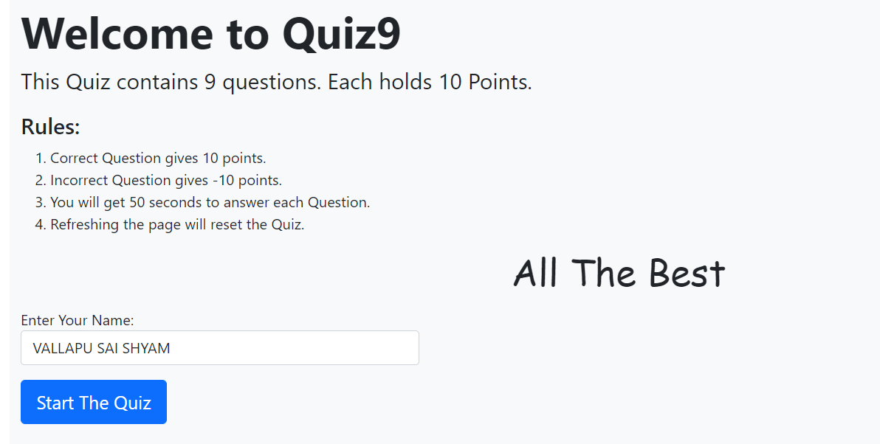
Question 1:
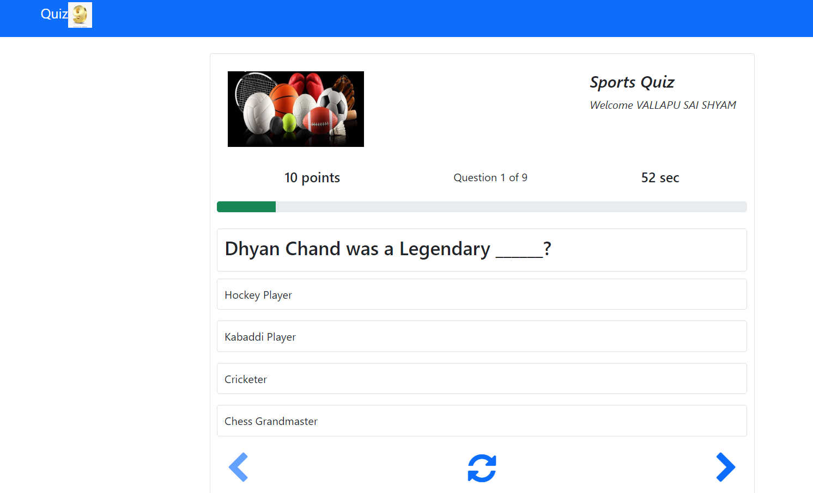

Final Result:
